|  |  |
| --- | --- |
| **PLAYER PROFILE** (Updated July 3, 2023)  **RIDHIMA KAPOOR** |  |

|  |  |
| --- | --- |
| **PERSONAL CREDENTIALS** | |
| Full Name | Ridhima Kapoor |
| Date / Place of Birth | December 10, 2014 / Chennai, India |
| Nationality | **Indian** – Lives in Bengaluru , India |
| Parents Name | * Prateek Kapoor * Gauri Kapoor |
| Parents Current Residence & Postal Address | 4143, Sobha Santorini , Sobha City , Thanisandra Main Road , Bengaluru – 560077 Mobile: +91 8939933558  e-mail: [leanprateek@gmail.com](mailto:leanprateek@gmail.com), [gauriesingh@gmail.com](mailto:gauriesingh@gmail.com) |
| Permanent Address | 4143, Sobha Santorini , Sobha City , Thanisandra Main Road , Bengaluru – 560077 Mobile: +91 8939933558  e-mail: [leanprateek@gmail.com](mailto:leanprateek@gmail.com), [gauriesingh@gmail.com](mailto:gauriesingh@gmail.com) |
| Educational Background | * Currently studying in Grade – III at DPS Bengaluru, North |
| Coaching Details | * Currently coached at To The Tee Academy , Bengaluru – Karnataka   + Coached by Mr Abdul Raheem KH   + Coached by Mr Mohammad Arif   + Coached by Mr Ajay Krishnan |
| Golf Membership | * TROON GOLF Membership with Prestige Augusta Golf Village (JGM1405) * The Indian Golf Union – Junior Associated Card (IGU-0555-J) * Applied for membership at Karnataka Golf Association – Membership Pending |

|  |
| --- |
| **BREIF DESCRIPTION** |
| Ridhima has always been an individual who learns her crafts from the get-go. She has been learning and training as a golfer from the age of 7 at the To The Tee Academy, Bengaluru. The result of this early start can be seen with the help of his accolades and constant improvement. She has sacrificed other sports and activities to focus on golf fulltime.  Ridhima aspires to be a professional golfer through her hard work, dedication, passion and talent. She has always shown the desire to keep improving and learning as an athlete and as an individual. Her dream is to win Olympics Gold for India and represent and win LPGA |

|  |  |
| --- | --- |
| **PLAYER PROFILE** (Updated July 3, 2023)  **RIDHIMA KAPOOR** |  |

|  |  |
| --- | --- |
| **PERSONAL ACCOLADES** | |
| Golf Endeavor | Year 2022   * Second runner up: Indian Golf Union Sub Junior South Zone Golf Championship at Coimbatore Golf Club CGC, Coimbatore, India played on   19 – 20 April 2022.   * First runner up: Indian Golf Union Sub Junior South Zone Golf Championship at Tamil Nadu Golf Club TNGF, Chennai, India played on   06–07 September 2022.   * Second runner up: Indian Golf Union Sub Junior South Zone Golf Championship at Madras Golf Club MGC, Chennai, India played on   09-10 September 2022.   * Second runner up: Indian Golf Union Sub Junior South Zone Golf Championship at Cochin Golf Club CIAL, Cochin, India played on   29 – 30 October 2022.   * Winner: Indian Golf Union Sub Junior South Zone Golf Championship at Coorg Golf Club CGL, Coorg, India played on 29 – 30 November 2022. * Winner: Indian Golf Union Sub Junior South Zone Golf Championship at Madikeri Golf Club MDGC, Coorg, India played on 02– 03 December 2022. * Winner: Hyundai National Interschool Regional Golf Trophy at Prestige Golf shire, Bangalore, India Played on 2nd November 2022. * Second runner up : Hyundai National Interschool Golf Trophy at Prestige Golfshire , Bangalore , India played on 3rd November 2022. * Overall, Winner – E Category IGU Sub Junior South Zone – Yr 2022   Year 2023   * First runner up: Indian Golf Union Sub Junior South Zone Golf Championship at Coorg Golf Links, Virajpet, India played on   14–15 Feb’ 2023.   * Winner: Indian Golf Union Sub Junior South Zone Golf Championship at Madikeri Golf Club MDGC, Coorg, India played on 17– 18 Feb’ 2023 * Winner: Indian Golf Union Sub Junior South Zone Golf Championship at Coimbatore Golf Club , Coimbatore , India played on 18th -19th April’2023 * Winner: Indian Golf Union Sub Junior South Zone Golf Championship at Kodaikanal Golf Club , Kodaikanal , India played on 22nd -23rd April’2023 * Winner: Indian Golf Union Sub Junior South Zone Golf Championship at Ooty Golf Club , Nilgiris, India played on 26th -27th April’2023 * Winner : Indian Golf Union Sub Junior South Zone Golf Championship at Bangalore Golf Club , Bengaluru , India played on 16th -17th May’2023 * Second Runner up – Prestige Augusta Junior Championship 2023 in combined category of Boys and Girls on 18th June’2023 * First Runner Up : Indian Golf Union Sub Junior South Zone Golf Championship at JWGC , Mysore , India played on 27th -28th June’2023 |
| Recognitions | * Winner E Category South Zone – Year 2022. * Won Master Class with Aditi Ashok for winning the Hyundai National Interschool Golf Championship. * Won Younger Achiever’s award on Sports Day at DPS Bengaluru North for the year 2022. * Won Aon Internal Challenge and won the Minjee Lee & Scottie Scheffler   signed Golf Pins |
| Yoga | * Brand Ambassador / Promotor of Prajna Yoga with Art of Living Bengaluru |
| Media Presence | * Hindu Article * Article in “She the People” - [How 8-Year-Old Ridhima Kapoor Found Her Rhythm In Golf (shethepeople.tv)](https://www.shethepeople.tv/interviews/ridhima-kapoor-junior-golfer/) * GolfPlus Magzine – Dec’Edition 2022 * Kreedon - [Ridhima Kapoor Biography | Sport, Family, Career, Achievements (kreedon.com)](https://www.kreedon.com/ridhima-kapoor-golf-player-biography/) * [Indian Golf Union Tour: 8 YO Bengaluru Girl Ridhima Kapoor Delivers Stellar Performance With Three Back-To-Back Wins | Newsmobile](https://newsmobile.in/articles/2023/05/02/indian-golf-union-tour-8-yo-bengaluru-girl-ridhima-kapoor-delivers-stellar-performance-with-three-back-to-back-wins/) |

|  |  |
| --- | --- |
| **PLAYER PROFILE** (Updated July 3, 2023)  **RIDHIMA KAPOOR** |  |

|  |
| --- |
| **PICTORIAL EVIDENCE** |
|  |
|  |
| |  |  | | --- | --- | | **PLAYER PROFILE** (Updated July 3, 2023)  **RIDHIMA KAPOOR** |  | |
|  |
|  |

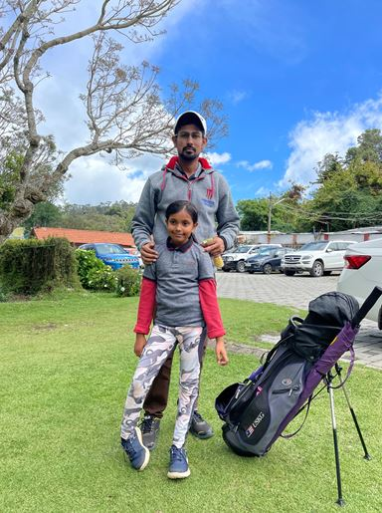 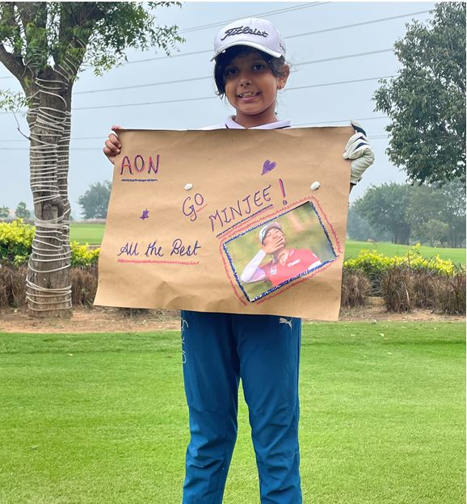 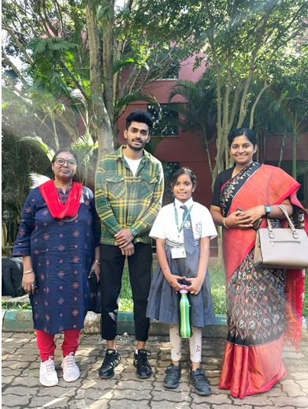

|  |  |
| --- | --- |
| **PLAYER PROFILE** (Updated July 3, 2023)  **RIDHIMA KAPOOR** |  |

|  |
| --- |
| **PICTORIAL EVIDENCE** |
|  |
|  |
|    |  |  | | --- | --- | | **PLAYER PROFILE** (Updated July 3, 2023)  **RIDHIMA KAPOOR** |  |    |  |  | | --- | --- | | **PLAYER PROFILE** (Updated July 3, 2023)  **RIDHIMA KAPOOR** |  |     A screenshot of a phone  Description automatically generated with low confidence  A group of people holding medals  Description automatically generated with medium confidence      A group of people standing in front of a banner  Description automatically generated with medium confidence |